# Accessing ERS’ Internal Copy of NASS Quickstats

ERS has a SQL table that contains an up-to-date copy of the [NASS quickstats census and survey data](https://quickstats.nass.usda.gov/) that you can use to programmatically query from.

**The survey and census data views are stored in the following location:**

Server: SQLprod01

Database: NASSQUICKSTATS

Schema: NASSQSFTP

Survey View name: NASS_QuickStats_Survey

Census View name: NASS_QuickStats_Census

As of 7/26/2016, the survey table contained about 15.7 million records.

Reviewing columns

There are 41 columns that can be broken down into four major categories of columns

The “What” columns

The “Where” columns

The “When” columns

The “Data value” columns

Note: Column names in database do not match headings on the Quickstats website. There are also additional columns in the database that are not published on Quickstats.

Here are two ways to access the database:

#1 Directly through SQL server management Studio

Step 1: Open SQL Server Manamgement Studio, type sqlprod01 as the server name, and press connect.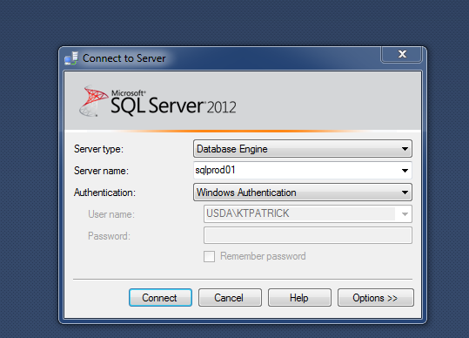

Step 2: Open the databases folder

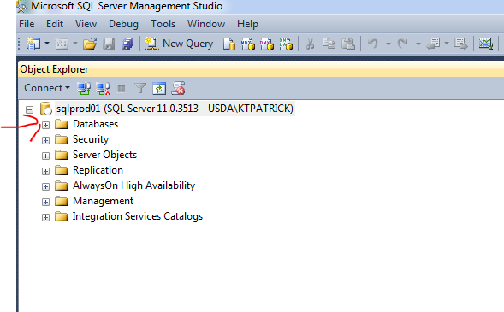

Step 3: Open the NASSquickStats database

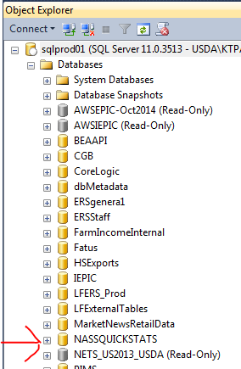

Step 4: Open views

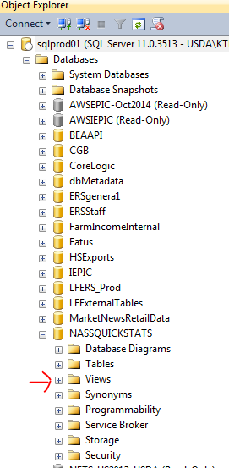

Step 5: Right click on the NASSQSFTP.NASS_QuickStats_Survey view and choose “Select top 1000 rows”

This will bring up a sample query that you can edit.

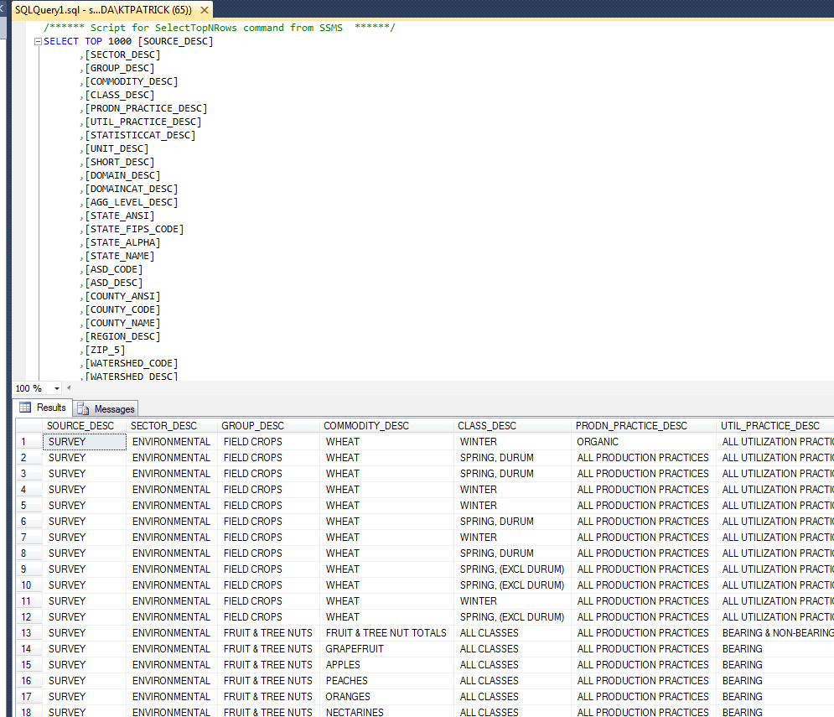

Second method to access NASSQS we’ll cover is through SAS. See sample queries below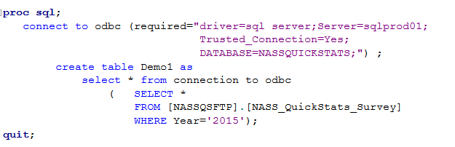

Alternative code:

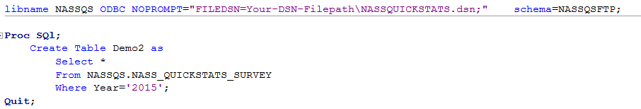

With this code you will need to save a text file with a .dsn extention with the following information in it:

[ODBC]

DRIVER=SQL Server

DATABASE=NASSQUICKSTATS

Trusted_Connection=Yes

SERVER=SQLPROD01